Personal portfolio 2
My name is Eric, a developer of TNT team. We made a cloud server called “Mediavault” to save users’ media files, like e-book, picture, video, audio online. Obviously, the solidarity and precise division is necessary for a group to finish their project, especially for this large project. So, in my group, the division of labour is clear-cut, each one being charged with specific responsibilities. And my job is to build the account system.
A good and safe account system is important for the users, because no one want to lose their account and data. In order to release the functions, I do somethings below:

- Modify the password.
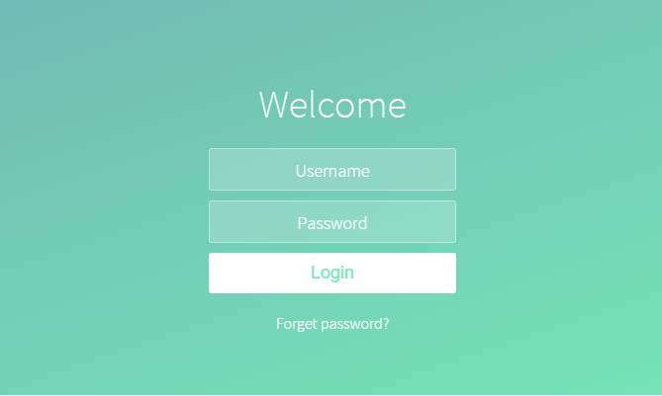
Sometimes, people forget their passwords and cannot login the system. So, I created the “modify password” function in order to help some people to retrieve their password. And users are asked to input their email address (used to create account before). If finished, the system will send an email to user which is used to retrieve the password.
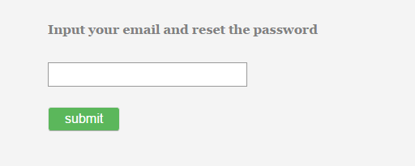
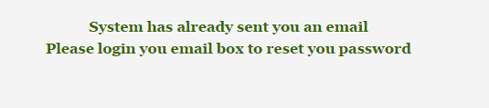
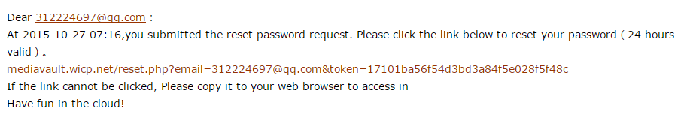
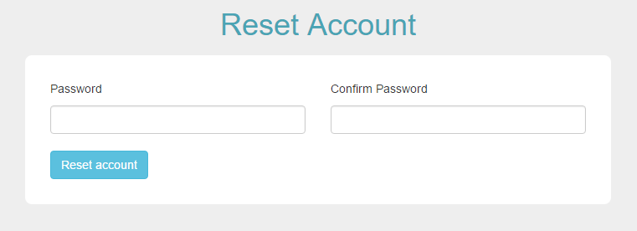
Users can modify their password now.

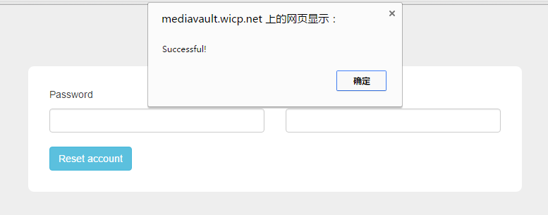
If successful, the page will link to “log in in”, and users can use their new account to access to the media vault
Obviously, a fully integrated system is so important.

- Log in by email address
Sometimes, users want to combine the user name with their email address. So, I created the “log in by email” function. It is so convenience for users to remember their account, just use email address and password to log in.
I use php and database techniques to release this function. (Combine user name with the email address).
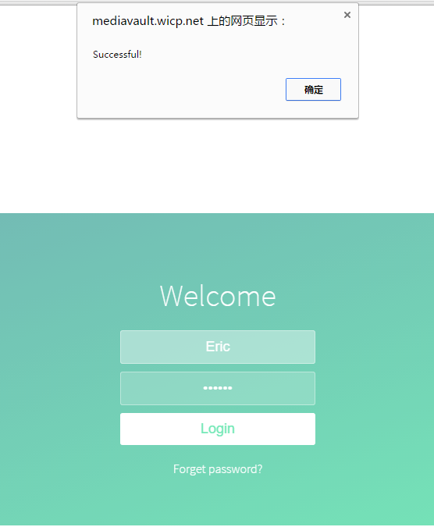

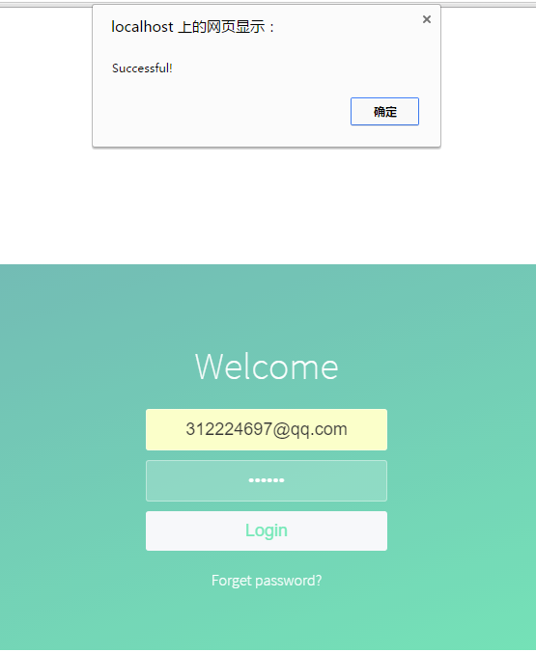
- Session
The most important function for media vault is private page(private zone). And the core technique is “session”. “session” is used to get user’s id and user’s name when they log in the system. Then “session” will tell other pages who logs in the system and these pages will display all files or information which are relevant to the user.
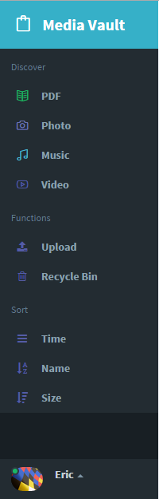
As can be seen from this picture, Eric logs in the media vault. So, the user center shows his name and photo.
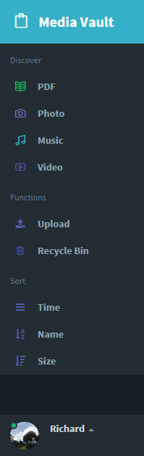
Now Richard logs in. And the user center shows his name and photo.

So, session is very important to release the private zone function.

4.
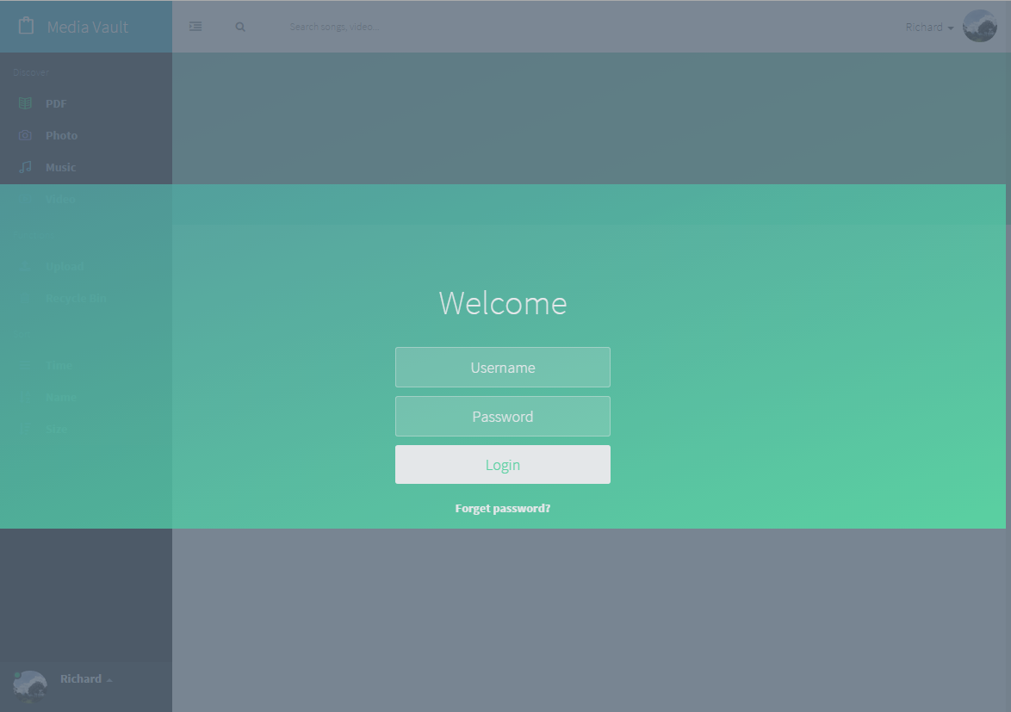
The picture above shows the “log out” function. When users want to switch the account, they can use this function. When they log out, system will show the “log in” page, and another user can log in the media vault.
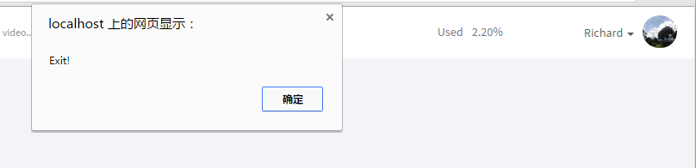
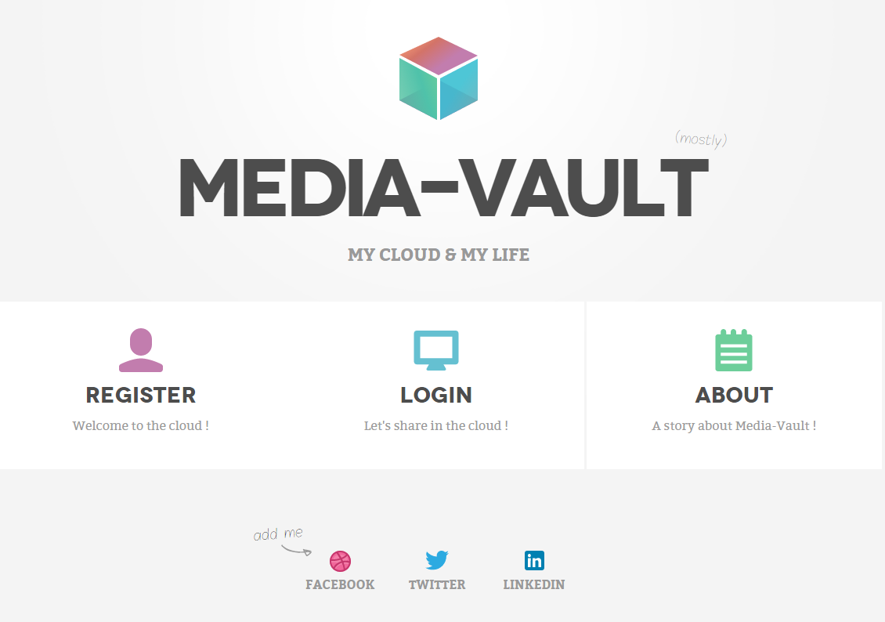
This picture shows the “exit” function. When users exit their account, the page will return to the “welcome” page.
Most importantly, when user exit, the “session” will be destroyed. That means system won’t have their any information any more. If users want to open “home page” directly, they are not allowed to access.

- Destroy session
If users want to open “home page” (or “profile page”, etc) directly, they are not allowed to access. The picture below shows the error information. Because I the session has already been cleaned after they log out or exit.
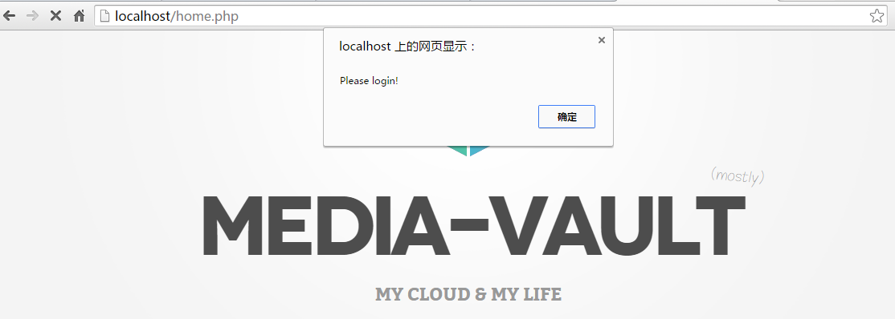
I

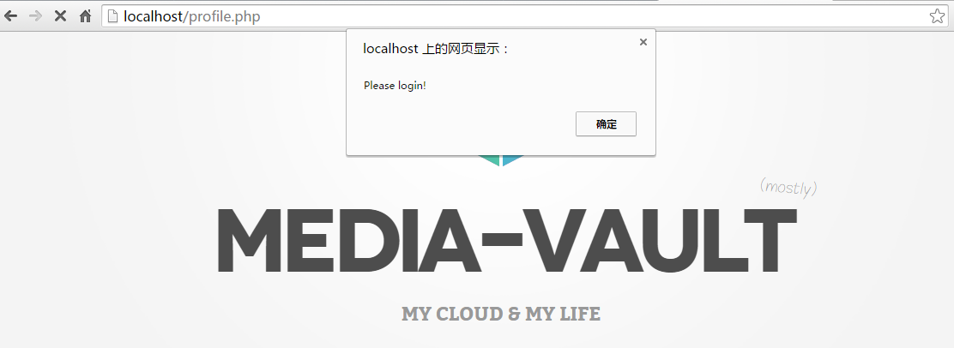
That is very important, because no one want personal information to be surrendered. So, no one can open someone’s home page without using his account. So, that is the reason why I create this function.

- Normalize picture
People always want to see the tidy layout. So, I use html “height” and “width” functions to normalize the size of the pictures uploaded by users. That looks so beautiful and tidy.
